From: https://davidstockmanscontracorner.com/batten-down-the-hatches-the-turbulent-twenties-lie-dead-ahead-part-1/

Batten Down The Hatches: The Turbulent Twenties Lie Dead Ahead, Part 1
By David Stockman. Posted On Thursday, December 19th, 2019
The Turbulent Twenties begin 13 days from now. It will be the decade when the chickens come home to roost and a time when the cans of denial and delay can no longer be kicked down the road.
Instead, the 2020s will mark an era when today's economic and political fantasies give way to:
- the spectacular failure of Keynesian central banking;
- a violent implosion of America's fiscal accounts;
- a prolonged, painful reversal of the three-decade long hyper-inflation of financial asset prices that has resulted in the Everything Bubble;
- a ferocious global economic headwind arising from the demise of the Red Ponzi;
- an outbreak of unprecedented partisan acrimony rendering Washington completely dysfunctional and imperiling America's very constitutional foundation;
- the lapse of Imperial Washington into retreat and failure all around the planet;
- a grinding halt to US economic growth while the Baby Boom retirement tsunami causes entitlement spending to soar and generational conflict to erupt like never before; and
- a virulent outbreak of class warfare and redistributionist political conflict unprecedented in American history owing to a stagnanting economic pie.
These baleful developments are not just possibilities---they are well nigh certainties.
And they are ultimately rooted in a common cause. Namely, the three decade long explosion of debt and speculation that was initiated in October 1987 when Alan Greenspan bailed out Wall Street speculators and launched what has become a toxic worldwide regime of Keynesian central banking.
Consequently, America is today saddled with $74 trillion of public and private debt, while the global figure exceeds $250 trillion. However, these Brobdingnagian figures did not materialize during the last three decades because everyday people suddenly lost their senses and became addicted to unsustainable levels of debt, leverage and financial speculation.
To the contrary, the people here and abroad were misled, induced and baited into burying themselves under crushing debts by agents of the state---especially its central banking branch. The means were
- falsified interest rates,
- artificially inflated asset prices and
- a hoary theory that debt-fueled "stimulus" injections by the state can create a permanent increase in economic growth and societal wealth.
Actually, as an economic scoring matter, incremental debt does purchase added GDP in the current period as per the defective national accounting conventions promulgated by Keynesian economists more than a half-century ago. But GDP accounting is inherently incomplete because it views the economy as simply a matter of period by period flows---the more "spending" the better---without regard to balance sheets and the accumulated cost of debt carry over time.
Moreover, this Keynesian blindness to balance sheets and their systematic impairment has gotten far more consequential since Greenspan launched a wholly new form of monetary central planning in October 1987.
That's because the price of debt has been deeply and systematically falsified by the central banks, thereby providing a powerful artificial incentive to borrow and a misleading signal to debtors about its longer-run implications.
In the case of households and governments especially, balance sheets have been deeply impaired in order to fund current spending, yet these two sectors virtually by definition do not borrow in order to acquire productive assets capable of defraying the accumulating cost of carry. At length, therefore, they suffer a progressive diminution of their ability to spend as interest costs on past spending/borrowing absorb an ever larger share of current income.
Even in the case of the private business sector, where borrowings used to fund new assets can add value if they generate returns in excess of the cost of debt, the relentless central bank repression of interest rates has resulted in severe balance sheet deterioration, which over time means reduced growth and wealth generation.
That's because the cost of benchmark debt (i.e. the 10-year U.S. treasury note) is really the master cap rate for the entire financial market. Artificial and sustained reduction of cap rates result in proportionately higher asset prices and increased price/earnings multiples.
Yet cheaper debt and richer share prices are one of the most toxic consequences of Keynesian central banking. It provides powerful incentives to the corporate C-suites to borrow at sub-economic costs and use the proceeds to fund stock buybacks, thereby increasing per share earnings which trade at elevated PEs.
Likewise, cheap debt causes a huge distortion in the M&A market. Acquisitions are made to look "accretive" not because the make business sense or because there are true, sustainable synergies, but because they carry cost of purchase debt is so low.
Needless to say, these forms of financial engineering redistribute financial wealth to the top 10% and 1% of households, which own 40% and 85% of the stock, respectively. But that comes at the expense of reduced investment in productive assets and therefore lower growth and employment over time.
At the end of the day, the relentless and ever deepening financial repression of the last 30 years has generated modest one-time gains in output and jobs on main street and a massive one-time inflation of financial asset prices on Wall Street.
But now the bad money regime of the Keynesian central bankers has finally taken itself hostage. The central bankers have fostered such massive and egregious bubbles that they are literally terrified by the prospect of another stock market meltdown like those of 2000 and 2008-2009, which, in turn, would bring a renewed bout of desperate restructuring, layoffs and asset liquidations in the C-suites and a new bout of recession on main street.
So the Fed has simply launched a hail mary which is so transparent and incendiary that it will surely catalyze the final blow-off top early in the 2020s.
After all, there is not an iota of financial learning extant prior to 2007 that could possibly justify its recent panicked actions. They will result in $500 billion of repo facilities and T-bill purchases by the turn of the year (and decade!) at a time when unemployment is at a 50-year low and the stock indices are at nose-bleed highs.
Indeed, right now the catalyst which will blow off the roof of false prosperity as we enter the 2020s is brewing in the chart below. So to recap, here is where it stands.
The Bernanke Fed falsely claimed it was facing a rerun of the 1930s, and pumped the Fed's balance sheet from $880 billion in November 2007 to a peak of $4.5 trillion in February 2015. That is, in less than eight years it printed 5X more fiat credit and injected it into the canyons of Wall Street than the Fed had generated during the first 93 years of its existence.
As we will show in Part 2 and beyond, however, that eruption did virtually nothing for the main street economy---even as it distorted, falsified and inflated financial asset prices beyond all recognition.
Then during the next three years---from early 2o15 to the fall of 2017----the Fed dithered and delayed shrinking its balance sheet back to pre-crisis levels, as Bernanke and the rest of his band of drunken monetary sailors insisted they would do when the QEs were launched during the crisis.
Worse still, after a tepid 15% retrenchment during 2018 through August 2019, the Fed turned tail and ran in the face of bitter attacks from the White House and unrelenting pressure from the bully boys and crybabies of Wall Street.
And now the last bit of sanity in the Eccles Building has vanished. From a low of $3.76 trillion on August 28, the Fed has already pumped $377 billion into the bonds pits. That represents a staggering $1.1 trillion annualized rate of expansion and brings its balance sheet back to $4.14 trillion as of last Wednesday, and heading toward well beyond the old high water mark of $4.5 trillion early in 2020.
That's the great monetary match. The stock indices have now been entirely disconnected from earnings, which have declined for four straight quarters, and economic fundamentals, which are heading into the recessionary drink, beginning with hardly 1.0% GDP growth in the current quarter.
Stated differently, the repo ruckus last September was the warning bell that the 30-year era of Bubble Finance was fixing to blow.
But the fools in the Eccles Building, blindly fixated on enforcing their interest rate pegs, effectively got out a gasoline hose and fueled what is now the blow-off top. And that will pave the way for the Turbulent Twenties, and for the unfolding of all the baleful factors listed above.
Stay tuned for why and how this coming era of payback will all play out.

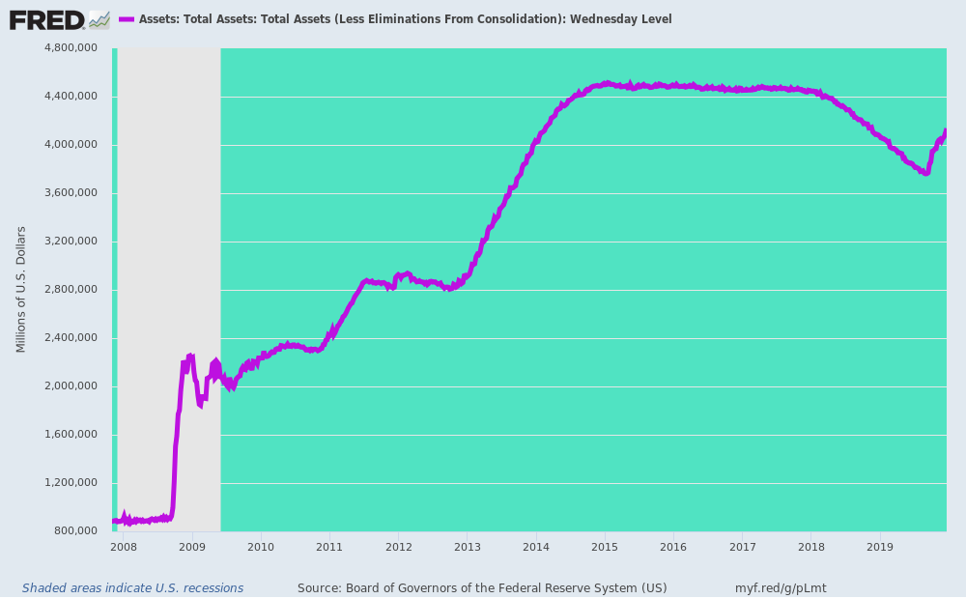

__________________________________________________________________________________________________

Batten Down The Hatches: The Turbulent Twenties Lie Dead Ahead, Part 2
By David Stockman. Posted On Friday, December 20th, 2019
From: https://davidstockmanscontracorner.com/batten-down-the-hatches-the-turbulent-twenties-lie-dead-ahead-part-2/
The Turbulent Twenties and the coming baleful trends outlined in Part 1 have been gestating for decades in the chart below. Their driver and most visible manifestation is the nation's crushing public and private debt levels, which now total $74 trillion, and the implied national leverage ratio, which has essentially tripled since the halcyon days of the mid-1950s.
So we start with long view of debt and GDP because one toxic consequence of Keynesian central banking has essentially been the abolition of financial history. The market narrative is so oppressively focused on the most recent days, weeks and quarters that today's perverted financial structure is unthinkingly presumed to be normal, stable and sustainable.
It is not.
What was "normal" is evident in the figures for mid-1954---a time when the distortions of World War II and the Korean War were pretty much behind and the US economy had embarked upon an extended period of solid growth, low inflation and financial stability.
At the time, total public and private credit market debt stood at $544 billion and GDP posted at $391 billion, yielding a national leverage ratio (Debt/GDP) of 1.39X. Incidentally, this national leverage ratio had oscillated narrowly around 1.5X for nearly a century extending back to the break-out of strong industrial growth after 1870.
Not surprisingly, the true inflection point came in mid-1971 on the eve of Tricky Dick Nixon's folly at Camp David. During the intervening 17 years between 1954 and 1971:
- Real GDP growth had averaged 3.8% per annum and inflation had remained low most of the period;
- Nominal GDP had grown by 6.6% per annum and total public and private debt by 6.9%.
As a result of nominal GDP growth and debt growth tracking nearly on the same path, the national leverage ratio changed hardly at all---even though real growth and inflation posted the best 17 year trend of the 20th century. That is, the golden era of post-war prosperity occurred with virtually no change in the national leverage ratio at all---the boom was organic and a product of capitalism at work.
Thus, by the eve of Camp David, total credit market debt stood at $1.70 trillion and nominal GDP posted at $1.16 trillion, representing a national leverage rati0 1.47X.
Going back during the previous century of robust U.S. growth and rising middle class prosperity, a leverage ratio of 1.47X was par for the course, meaning that the US economy was still on course when Nixon pulled the plug on Breton Woods and the gold-anchored dollar.
At that point, however, the black area of the chart (total debt) begins to break away from the purple area (nominal GDP), meaning that the nati0nal leverage ratio began its long ascent from its historic 1.5X trend line. What followed between 1971 and 1987 was the raging double digit inflation of the 1970s, which had been triggered by a newly unshackled, money-printing Fed. and then the deep recession of 1981-1982, triggered by Paul Volcker's about face toward severe monetary restraint designed to smoother it.
As is evident from the chart, there were three recessions during that 16 year interval, which obviously did not do much for macroeconomic performance. Consequently, CPI inflation surged to 6.7% per annum over the period while real GDP growth retreated to 3.2% per annum.
By contrast, the debt and leverage ratio lept sharply higher over 1971-1987:
- Total credit market debt grew from $1.7 trillion to $10.7 trillion or by 12.2% per annum;
- Nominal GDP rose from $1.16 trillion to $4.8 trillion or by 9.3% per annum; and
- The national leverage ratio spiked from its historic channel at 1.47X in 1971 to 2.22X by June 1987
So the smartly rising level of debt and the national leverage ratio during that transition period did not deliver any economic goodness at all. A pattern of more leverage and less growth was already evident.
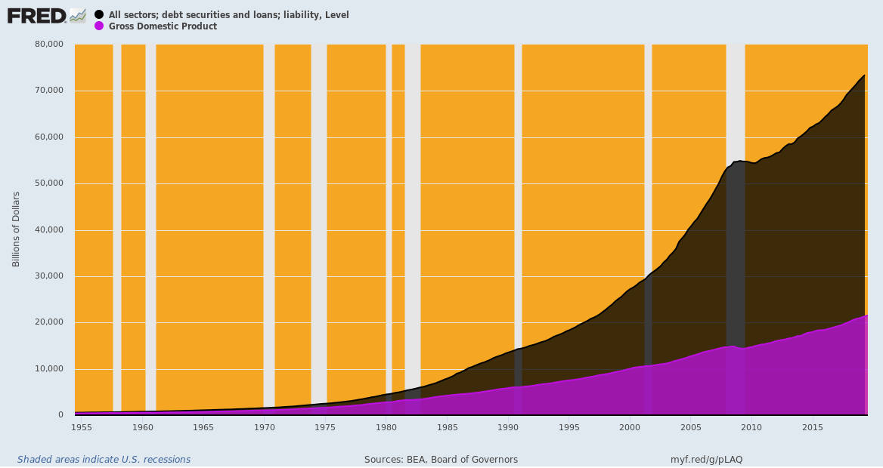
During the first thirteen years of the Alan Greenspan regime at the Fed, the national leverage ratio lept higher still. Between Q2 1987 and the inception of the tech stock meltdown in Q4 2000:
- Total debt grew from $10.6 trillion to $28.6 trillion, or by 7.6% per annum;
- Nominal GDP rose from $4.8 trillion to $10.4 trillion or by 5.9% per annum; and
- The national leverage ratio climbed to an unprecedented high of 2.74X
During the early period of the Greenspan money-pumping era, however, the resulting stimulus to Wall Street supported a capital spending boom and flowering of technology innovation and adoption on main street. Accordingly, CPI inflation remained reasonably subdued, rising at a 3.2% annual rate during this interval, while real GDP posted at 3.3% per annum---the same rate as during 1971-1987.
During the first seven years of the 2000s, however, the Greenspan Fed cranked its money printing policy into high gear, allegedly to reflate the economy after the mild recession of 2001, but, in fact, to bail out the punters on Wall Street, which had been hit by a 85% meltdown of the NASDAQ 100 tech stock mania. This time the leverage ratio soared yet again---even as main street economic performance deteriorated sharply.
- Between Q4 2000 and Q4 2007, total public and private debt outstanding soared from $28.6 trillion to a staggering $52.6 trillion. That amounted to a private and public debt gain of $3.4 trillion per year, representing a 7.9% per annum growth rate;
- Nominal GDP rose from $10.4 trillion to $14.7 trillion or at a far more modest growth rate of 5.6% annum; and
- The national leverage ratio literally erupted right off the charts, rising to 3.58X.
At the same time, real GDP growth weakened to 2.5% per annum and inflation remained at 2.4% per annum.
At that point the wheels came off the wagon: After $24 trillion of total debt growth and a soaring and wholly unprecedented leverage ratio at 3.58X national income, it was more than enough to send Wall Street crashing and the main street economy into the drink of the Great Recession.
After Q4 2007 everything changed. The US economy apparently reached a point of Peak Debt. Accordingly, while both total debt and nominal GDP continued to rise by huge amounts, the leverage ratio remained flat, albeit stranded up in the nosebleed section of history. During the 12 years between the pre-crisis peak in Q4 2007 and Q3 2019:
- Real GDP growth slowed sharply to just 1.66%---the weakest trend growth rate since the Civil War, including the 1930s;
- total US debt grew from $52.6 trillion to $73.4 trillion or by 3.0% per annum, notwithstanding the so-called wake-up call of the financial crisis;
- nominal GDP grew from $14.7 trillion to $21.3 trillion or by 3.3% per annum; and
- the national leverage ratio weakened very slightly to a still record high of 3.44X.
In short, the chickens were already beginning to gather for the trip home to roost in the Turbulent Twenties ahead. And the pattern was now clear. The nation's leverage ratio has been steadily ratcheting upwards for nearly 50 years, even as the growth rate of real GDP was being driven steadily lower after the turn of the century.
Stated differently, at the 1.47X leverage ratio extant on the eve of Camp David in June 1971, total credit market debt today would stand at just $31.4 trillion, not $73.4 trillion.
So the two extra turns of debt on national income amount to $42 trillion---a burden of incremental debt that is grinding the wheels of economic growth to a halt.
As we will show in Part 3, there is absolutely no doubt about how this baleful state of affairs came about. It is the work of the Keynesian monetary central planners domiciled in the Eccles Building and the other major trend-following central banks around the world.

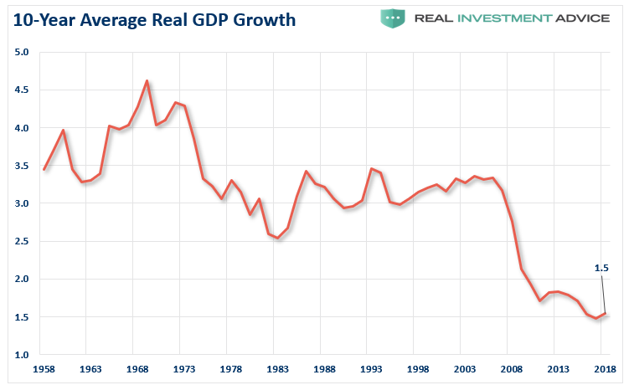
__________________________________________________________________________________________________

Batten Down The Hatches: The Turbulent Twenties Lie Dead Ahead, Part 3
By David Stockman. Posted On Friday, December 23rd, 2019
From: https://davidstockmanscontracorner.com/batten-down-the-hatches-the-turbulent-twenties-lie-dead-ahead-part-3/
Ironically, Donald Trump's harsh, unhinged and unrelenting attacks on the Fed are about as good a warning sign of the impending Turbulent Twenties as any.
That is, if even the Donald can see that the Fed has morphed into an all powerful monetary politburo that threatens the very survival of capitalist prosperity in America, then the end of the 30-year financial fantasy launched by Alan Greenspan in October 1987 must truly be at hand.
The truth is, like no other politician since December 1913 when the Federal Reserve System was mid-wifed into existence by the great financial statesman, Congressman Carter Glass, Trump has exposed its awful secret.
Namely, that what Glass intended to be a modest, economically passive "bankers' bank", which would provide back-up liquidity to the banking system against good commercial collateral at a penalty spread above the free market rate of interest, has become an intrusive instrument of plenary monetary central planning by an unelected priesthood of delusionary central bankers.
The emphasis here is on the word "passive". The kind of old-fashioned central banking on which the Fed was predicated in 1913 did not pretend to superintend the entire GDP or target the inflation rate or track the level of unemployment, housing starts, retail sales, CapEx orders, export volumes or anything else in today's constellation of so-called "incoming data".
Back then, most of these macro-economic aggregates had not yet been invented, let alone measured and tracked monthly and quarterly. And, in any event, the underlying level of main street economic activity and the growth rate of society's wealth was understood, properly, to be the business of capitalism, not the state.
The macro-economic variables that today's Keynesian central bankers obsess about, in fact, were way outside the remit of the Glassian Fed. The economic aggregates were taken as a given---the unwilled, unplanned, undirected outcome of millions of workers, entrepreneurs, investors, inventors, savers and speculators pursuing their own economic ends on the free market.
Accordingly, the Fed's far more modest assignment was to provide market-priced liquidity and to foster financial stability within the four walls of the commercial banking system. That modest assignment, in turn, reflected the belief that market-based capitalism would take care of the rest.
Not surprisingly, therefore, the original central bankers were to be green-eyed shade accountants and commercial bankers. That is, experts capable of assessing bank balance sheets and the credit value of commercial collateral (real trade bills backed by finished inventory or sold goods) presented to the 12-regional Reserve Banks for discount loans, not PhD economists who pretended to comprehend and direct a continental economy.
Needless to say, between then and now, the 19 central bankers who comprise the Federal Reserve Board have given "mission creep" an altogether new definition. In fact, the Fed has morphed into a rogue agency endowed with open-ended state powers to dominate the entire financial system; and, by manipulating and falsifying the price of money, debt and most other financial assets, to thereby shape the ebb and flow of the nation's entire $21 trillion economy.
So the Turbulent Twenties beckon for one reason above all others. To wit, the Fed's regime of monetary central planning inherently causes
- failure on the main street economy and
- unspeakable windfalls to Wall Street and the wealthy elites who own most of the financial assets.
We will treat later with the reasons and mechanics by which Keynesian central banking causes a massive shift in financial wealth to the tippy-top of the economic ladder. But suffice it here to note that since 1989, the share of US net worth attributable to the bottom 90% of households (purple line) has dropped from 33% to 24%, while the share held by the top 1% has soared from 30% to nearly 39%.
Contrary, to Dem and liberal propaganda, however, this isn't due to trickle-down tax policy. The low water market for tax rates was reached in 1986 when Ronald Reagan's landmark tax reform bill cut the top rate for all forms of income---wages, salaries, dividends and capital gains---to 28%. Since then rates have risen steadily higher on earned income and have been only modestly reduced on capital gains.
Accordingly, the driver of the chart below is bad money, not pro-rich tax policies. As we will fully develop subsequently, the Fed's massive balance sheet expansion since Greenspan took the helm---from $200 billion to $4.0 trillion or a 20X gain--is the culprit.
That's because in today's debt-saturated and globalized economy, Fed "stimulus" in the form of massive bond-buying and interest rate repression never leaves the canyons of Wall Street. It no longer causes credit-based growth spurts on main street---only relentless inflation of financial assets on Wall Street.
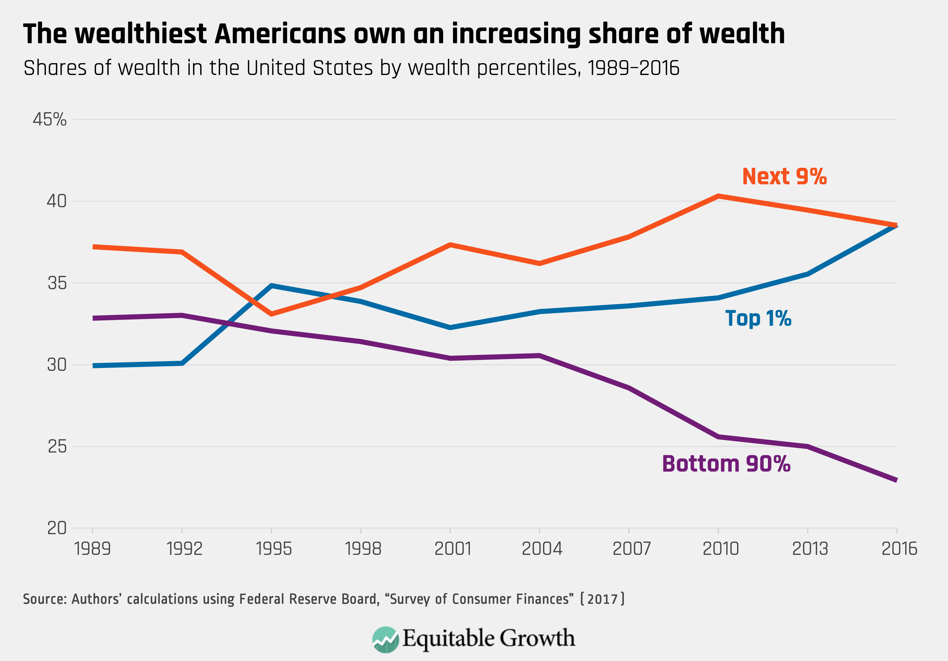
To be sure, the so-called Humphrey-Hawkins growth and inflation mandates are the cover story for this perverse regime. But in today's fully integrated $85 trillion global economy these purportedly sacrosanct mandates amount to an unattainable, threadbare farce.
So the Donald's everlasting service to whatever future prosperity may yet be attainable is this: Namely, the rambunctious calling-out in advance---and loudly and explicitly so---that the next financial crisis and resulting recessionary dislocation will be the sole responsibility of the Federal Reserve.
And that's something totally new under the sun compared to the servile Fed-fawning exhibited by Obama, Clinton and the Bushes who came before.
At the end of the day, sound money scribblers and even the "End the Fed" candidacy of Congressman Ron Paul couldn't break the spell---notwithstanding the truth of their case. They were and are marginalized by the mainstream financial press owing to the requisites of "access journalism" and the willful blindness of the corporate owners at the Wall Street Journal, Bloomberg, CNBC, Reuters and the rest.
But the Donald has a 60-million Twitter account, an audacious take-no-prisoners style of political modus operandi and a yawning empty space under the Orange Combover when it comes to even the rudiments of monetary policy.
But no matter. His crude political need to name and blame a scapegoat for the impending financial calamity---the Turbulent Twenties---is all that is required. That's because his conclusion about the Fed's culpability is absolutely correct, even if his hackneyed Easy Money reasoning comes from the deep bleachers in left field.
On Trump's call for even lower interest rates and a resumption of QE, of course, he is totally wrong, but the Donald will bag his institutional prey nonetheless. That's because unlike all of the other recent presidents---save for Ronald Reagan most of the time---who were totally choreographed, scripted, and moved their lips in the way that their advisors told them to on matters of monetary policy, the Donald is his own man when he hits the twitter keyboard.
Accordingly, the one thing that Donald Trump is going to accomplish in his misbegotten tenure is that his ferocious attack against the Federal Reserve will tear away the veil that it is a college of geniuses who are "beyond politics"; and that the Eccles Building and its 12 regional annexes are populated by high-minded technical experts in money wh0se essential work safeguards the prosperity of American capitalism.
To the contrary, the Donald's escalating war on the Fed----which is going to soon get far more vicious and heavy-handed---will tear apart limb-for-limb the arrogant pretensions of its 19-person monetary politburo, which has usurped control of financial and economic life in America, and, for that matter, on the fairest part of the planet.
Before the dust settles on the 2020 election, therefore, we believe that he will have totally besmirched and destroyed the credibility of the Fed, at least in the eyes of his base. At long last, there is going to be a popular-level political debate about central banking and what it actually accomplishes.
Needless to say, we relish the prospect. There is no way to get back to free market prosperity until our self-perpetuating cabal of Keynesian central bankers are politically lacerated and beaten to smithereens.
After the fragments end up all over the cutting room floor, we can figure out what to do next. But you must take down this institution first because the Fed is the #1, the #2 and the #3 enemy of prosperity, capitalism, free markets, individual liberty, and the wealth of people in America and in the world today.
Accordingly, the crucial starting point is debunking the Humphrey-Hawkins Act and the Fed's so called full-employment and inflation mandates.
As to the latter, the Fed does not have a prayer of creating inflation, let alone hitting with precision its specious 2.00% inflation target. Suffice it here to say that in an integrated global economy driven by central banks engaged in a race to the interest rate bottom, the bias of the financial system is toward over-investment, malinvestment and deflationary over-production.
Here's the smoking gun based on the Fed's loudly ballyhooed contention that the only valid measure of inflation is the PCE deflator, and that the periodic shortfall from 2.00% of the latter since inflation targeting was officially adopted in January 2012 is the principle reason for keeping interest rates pinned far below market clearing levels.
The purple line represents a popular commodity index which is heavily influenced by global energy and other raw material price cycles. As it evident from the right-hand scale, the year-over-year global commodity index swung from negative 30% during the near global recession of 2015-2016 to positive 30% during the 2017-2018 China credit fueled mini-boom, and then back to zero percent or less in recent months.
During that same seven-year period, the PCE deflator swung from 2.5% (over-shooting the target) to just 0.5% per annum during the 2015-2016 global slowdown. It then sprang back to 2.3% during the mid-2018 sugar high and is now back to 1.5%, which, in turn, has generated calls for more Fed easing owing to an alleged inflation shortfall.
This is downright risible nonsense. The Fed interest rate machinations, stop and go maneuvers on QE/QT and open mouth operations had little to do with the fluctuations in the PCE deflator. They were due to global forces far more powerful than the Fed's wet noodle policy maneuvers.
The implications of the chart below cannot be gainsaid. It completely debunks the very idea that the Fed is rationally pursuing higher inflation with its chronic policy of "accommodation".
What it is "accommodating", in fact, is the insatiable appetites for cheap money among its clientele on Wall Street.
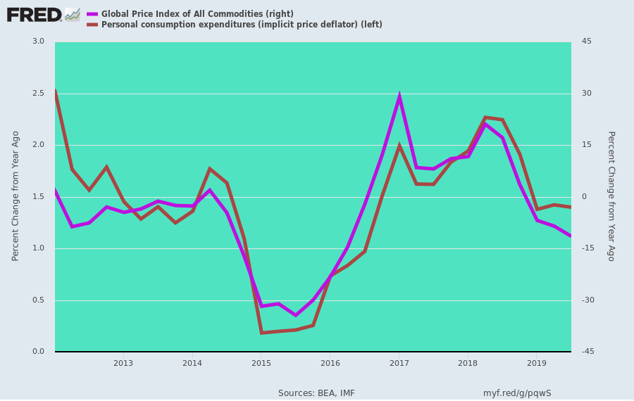
Likewise, the global regime of Keynesian central banking inherently careens toward massive and cumulating over-indebtedness. That's because at bottom there is no economic magic at all in its tired brand of borrow and spend "stimulus" enabled by cheap, falsified interest rates.
That policy panacea just pulls economic activity forward in time---at the cost of relentlessly accumulating debt and ever higher future preemption of income and cash flows for debt service. Yet once they are debt-entombed, economies are inexorably capable [only] of ever more modest rates of growth.
That truth is written all over the subway walls, as Simon & Garfunkel once put it. Between 2001 and 2007, for example, global debt rose from $86 trillion to $140 trillion. At the same time, global nominal GDP increased from $33 trillion to $58 trillion during that six year period.
That is, $54 trillion or new debt bought $25 trillion of new GDP.
By contrast, debt exploded from the pre-crisis level of $140 trillion to $255 trillion by 2019, while GDP rose to just $85 trillion during the 11-year cycle subsequent to the pre-crisis peak.
That is, in the latest so-called recovery, it took $115 trillion of new debt to generate just $27 trillion of additional GDP. That's $4 dollars of going into permanent hock for just $1 dollar of (temporary) current GDP.
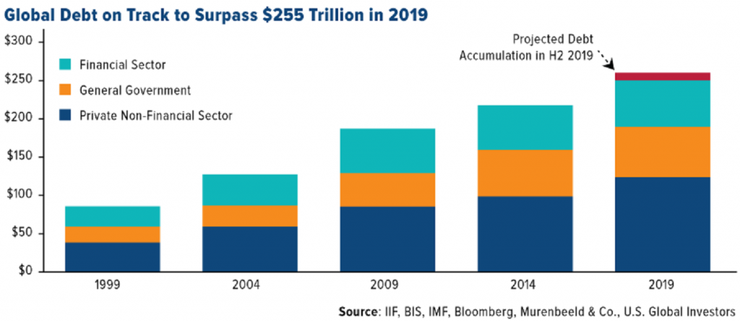
Self-evidently, that debt-fueled route to nominal GDP growth has played out. The household sector is at Peak Debt. And the business sector has been lured into massive financial engineering, not productive investment, by the speculative casino on Wall Street, which is the end product of Keynesian central banking.
As we indicated above, all that massive central bank stimulus in the form of fiat credit expansion never escaped the canyons of Wall Street and its counterpart financial venues around the world. And there, it did cause growth and inflation, but of financial asset prices only, and egregiously so.
Accordingly, asset prices are now precariously purchased in the nosebleed section of history----and not just stock prices, but bond prices, too. The $17 trillion of subzero yielding government and investment grade bonds in the world as of a few months ago are just hideously over-priced instruments of rank speculation.
But if you look at the charts, there are massive air pockets down below, let's say, the 2700 level on the S&P 500.
If there’s a shock event—like some tankers blow up in the Persian Gulf, or something really bad happens in the Taiwan Straits, or the Chinese pull some real retaliatory stunt like dumping a couple ten billion of UST bonds in a few hours—it could ignite the sell-off fuse on a market which is overwhelmingly machine driven, thereby tanking the whole applecart.
After all, 80% of daily volume in the stock market is essentially either indexed driven ETF's and mutual funds or various kinds of quantitative, machine-driven momentum-based investment strategies. If these carbon and silicon based chart-monkeys ever lose their numeric/formulaic footings, the market will drop through a deep air pocket, and then it's all over except for the shouting.
That is, if the S&P 500 drops 400, 500 or 600 points, you will trigger another go around in the corporate C-suites. They’ll suddenly wake up, like they did in October 2008, and say, "Oh my God, we've got too much inventory, we've horded too much labor, we've got a lot of M&A assets that aren't producing returns."
And then the corporate C-suites will go into these big restructuring programs, where they layoff workers by the tens of thousands, and they take huge write-downs, close facilities and extinguish underperforming assets in order to appease the trading gods of Wall Street.
The next thing you know, of course, you have a C-suite triggered recession. That's how it happens these days under the baleful regime of Keynesian central banking.
Recessions don't happen anymore because the Fed is tightening credit costs on Main Street. That's the old days. That's your grandfather's economy, and your grandfather's Fed.
But we're now in the era of Bubble Finance. The Fed basically inflates the financial system until it collapses, and then it spills over into the mainstream economy through these corporate C-suite panics.
So if the stock market cuts through the air pockets down below, the recession will happen instantly, and no one will see it coming—just like in 2008.
We remember well that in the spring of 2008 they were still talking about the Goldilocks economy. But in November 2008, they were talking about the end of the world.
This is exactly what we think will happen if the stock market breaks loose.
We don't know when it will happen. It could happen before November 2020, or after it. No one can really predict.
But we think the odds are that it will happen before the election, and if it does, the Donald is toast.
Under that scenario, Elizabeth Warren will be the next President of the United States, and as that prospect becomes ever more probable, the panic in the stock market will be something to behold. It will be worse than anything we've seen since October 1987.
Indeed, if the stock market is faltering in November 2020, or it has actually crashed, and the economy's in trouble, you’ll have a populist, redistributionist, big government, statist President and Congress.
That’s a totally different world than the fantasy that we've been living for the last 30 years.
And that's what's going to make the Turbulent Twenties an altogether different ball game.

